# Add permission

1) Add to Enumeration (BasePermissionenum.cs)

VenueAdmin = 8

Where 8 is Degrees of 2 (1,2,4,8,16,etc....)

2) Add to SMI

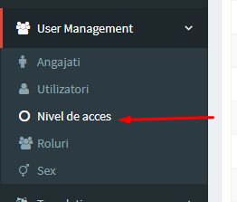 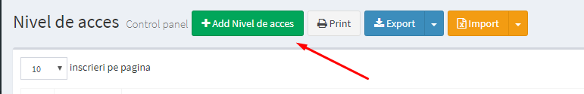 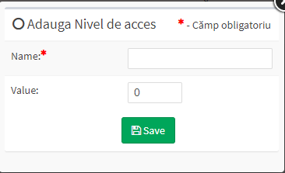

Value the same like in BasePermissionenum.cs

3) Add to permission Static Class

* public static readonly Permission VenueAdmin = new Permission(4, 8) { Name = "Venue Administrator" };

4 – Id from SMI

8 – the same like in Enumeration

* add to “LoadPermissions”

if (Tools.Security.Permissions.HasPermissions(Permissions, VenueAdmin.Value))

Perms.Add(VenueAdmin.Id, VenueAdmin);

* add to “LoadPermission”

if (VenueAdmin.Id == id)

return VenueAdmin;